
Please complete this form any time your son and his troop are scheduled for an outdoors activity.
Dearest parents and guardians,
This spring, the Any Town Boy Scouts are set to learn more about nature in order to fully appreciate its contributions to society. Thus, ___________________, along with the rest of his troop, is scheduled to explore and camp out in _______ on _______.
For any inquiries, please don't hesitate to contact me or our headquarters!
Thank you for your thoughtful consideration.

George Stewart
Any Town Boy Scout Leader

ANY TOWN BOY SCOUT CAMPING CHECKLIST:
Compass, Sleeping bag, Extra blankets, Lantern (with fuel or batteries), Matches or lighter, Eating utensils, Food storage containers, Trash bags, Water bottles, Biodegradable soap, Toiletries, Sunscreen, Insect repellant, Towels, Extra clothes, Swimsuit & Rain gear
------------------------------ CUT ALONG THIS LINE ------------------------------
Please fill up the form below and submit it before _________ to ensure your child's participation.
[ ] YES, I give permission for my child, _______________, to participate in this activity.
[ ] NO, I do not give permission for my child, ______________, to participate in this activity
because ___________________.
For emergencies, please contact me using the following details:
Phone number:
Mobile number:
Office number:
Home address:

Parent/Guardian  Signature over printed name | Date signed:  Date submitted:



Dear Jordan,
How are you?
My favorite time of the year is here again because it’s when I get reports on who has been good this year. My elves say you’ve been extra good, except for a few rough spots. (I know you’re sorry for that time when you took an extra cookie from the jar, and that’s totally okay.)
Keep on being good and you can expect some nice surprises come Christmas morning. So, tidy up your toy box, and your room, too! Share the toys you don’t play with anymore with other kids. And get the Christmas tree ready. You’ll need a lot of room for presents under it.

Sincerely,
Santa Claus





(Remember)
Immerse yourself in the practice of a focused morning journal — a powerful tool that can positively shape your mindset and well-being.

Date: Jun 7, 2024

Today’s Affirmation | Goal of the day

(To Do) Priority of the day:
Priority 1
Priority 2
Priority 3

(Thoughts)
Set intentions for clarity, vitality, and inner peace, and feel the positive impact throughout the day.
(Morning Rituals Checklist)
Roadmap to an energized and purposeful start.
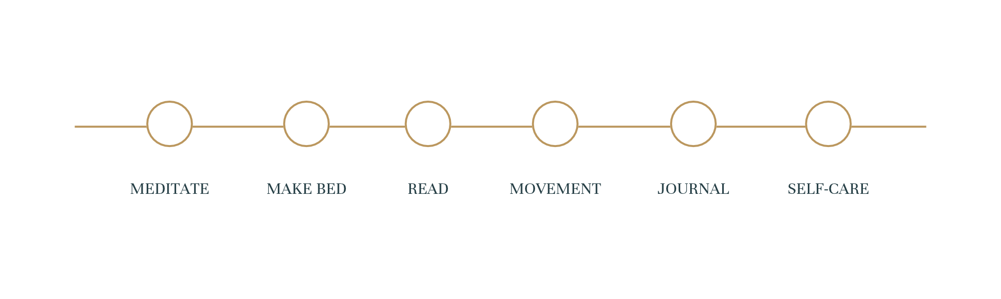

 | TO START |  | DELAY
 | OK |  | STUCK
 | CANCEL



The following table presents a one-month content plan designed to consistently increase brand awareness, engagement, and conversions through relevant, scheduled content across each digital platform.

Days | Content Type | Content Themes | Objective | Platforms
Monday | Feed Post
Tuesday | Feed Post
Wednesday | Reels/Videos
Thursday | Feed Post
Friday | Corousel
Saturday | -
Sunday | -

